* Files with “test” in the name something we want to keep moving forward?
  + Any important features in files with “_test” in the name?
* How will the “internal/restmachinery” directory fit in to the typescript SDK? Will they need to be converted or will they be separate from it?
* **Answered:**
  + Understanding how the colons work (EX: Lines 40-42 of client.go)
  + internal/restmachinery/client.go 131-134: Understanding this function declaration and its structure
  + (For the first question): Test files will be really important to make sure that functionality is working properly. Though the V 1.0 files may not transfer over, we should consider having new ones in V 2.0
* **(Notes on diagram visual presentation):**
  + 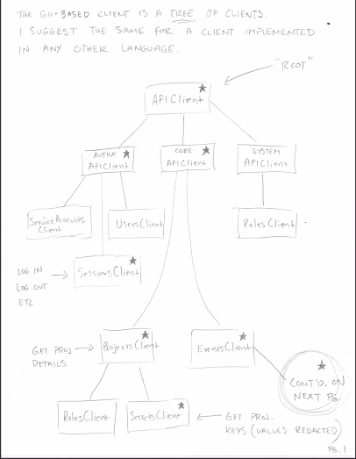
  + Authx is authentication (authx) and authorization (authc)
    - Sessions client (starred items are the most important!)
    - ***UNSTARRED ITEMS DO NOT NEED TO BE PORTED OVER (FOR NOW)

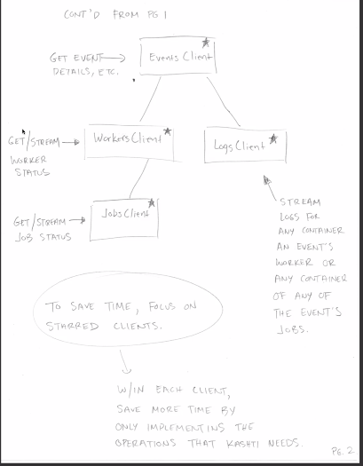

* Again, follow the starred sections for the most part

(Understanding the most relevant things without having to understand go):

- 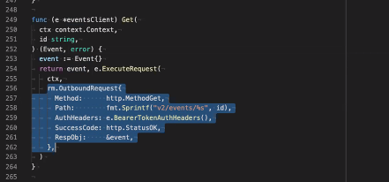

- This is in the API client.go